**DAY 5- INTRODUCTION TO ARRAYS AND STRINGS**

**Khushi Agrawal**

**Java batch 1**

**Session-1**

1. Write Java programs to create an array an initialize and print the elements.

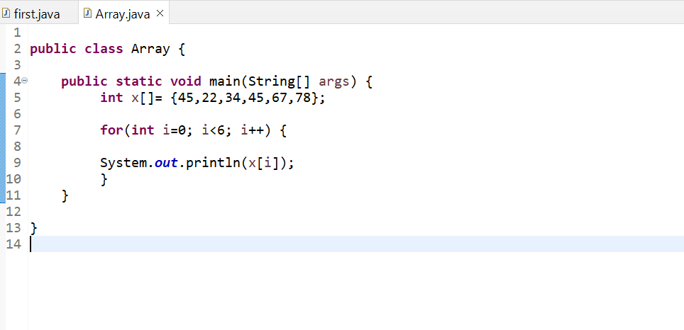

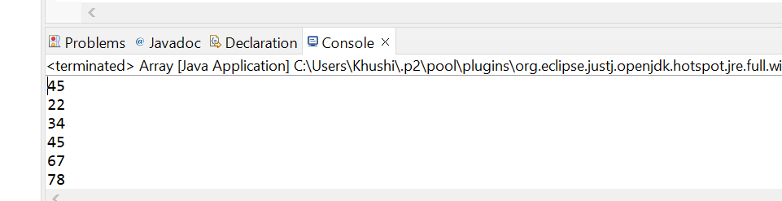

1. Calculate the average of numbers using Array.

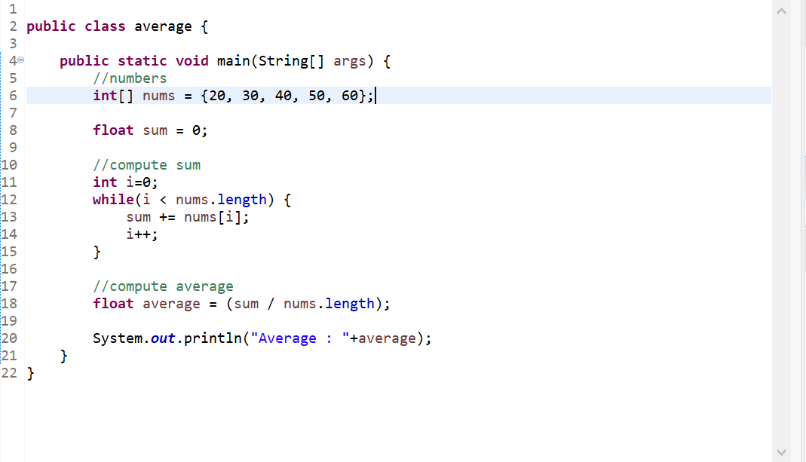

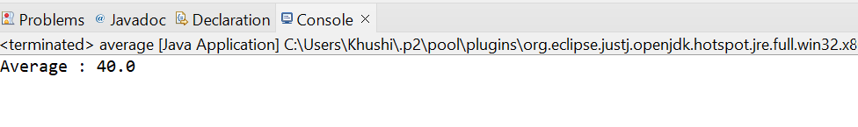

1. Find out the min numbers in an array.

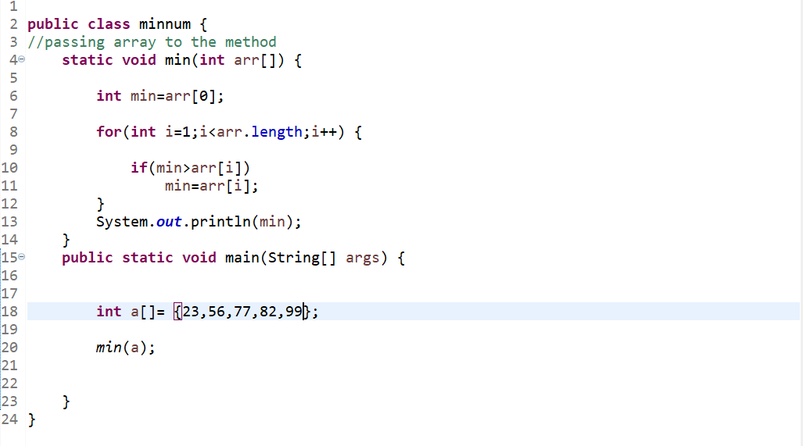

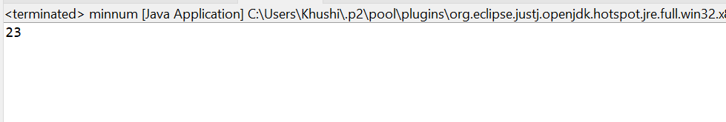

1. Convert char Array to String

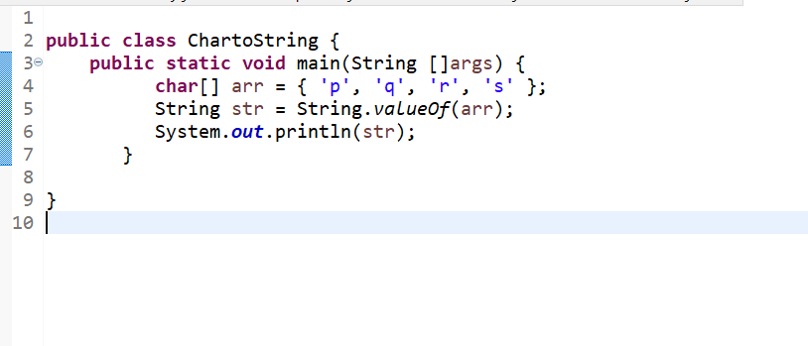

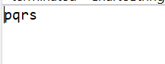

**SESSION 2**

1.

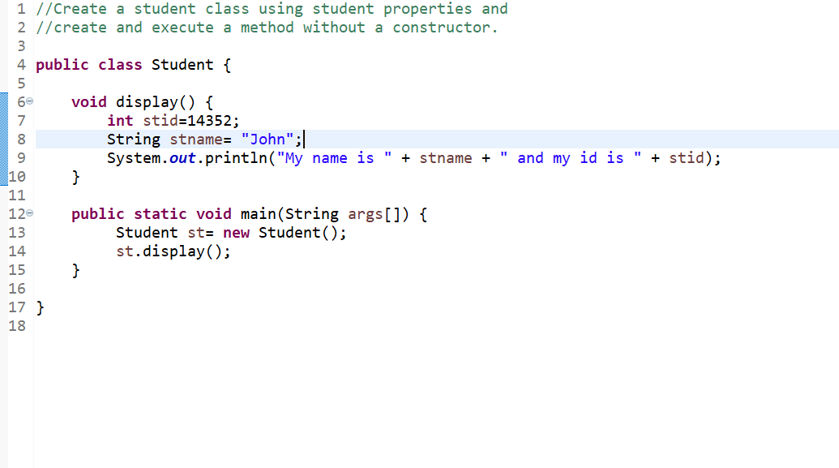

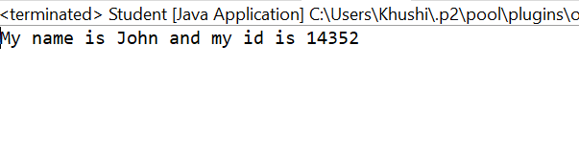

2.

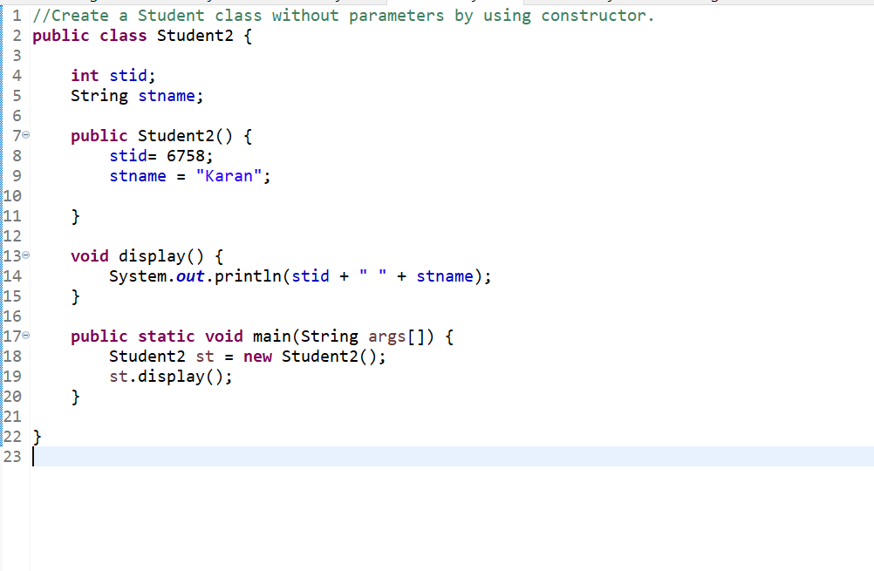

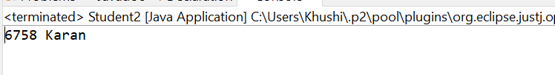

3.

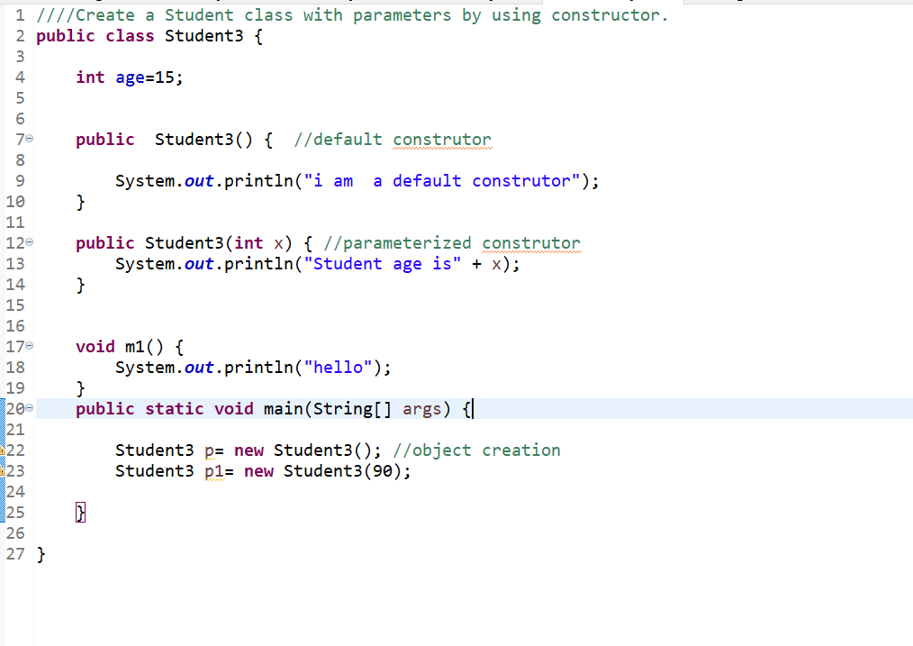

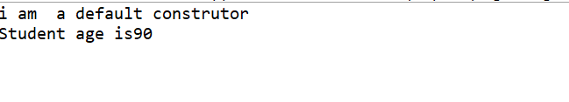

4.

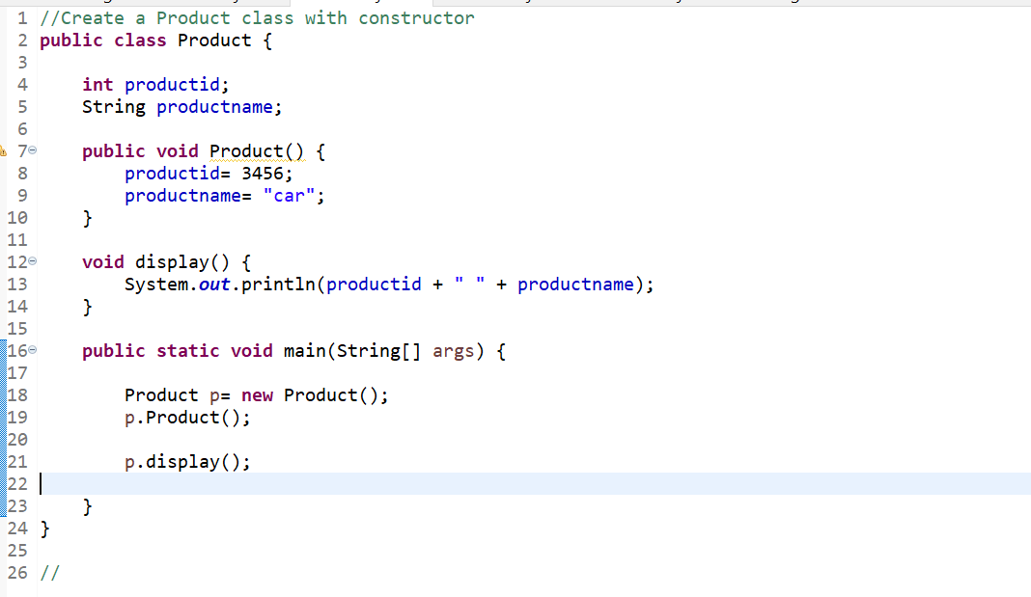

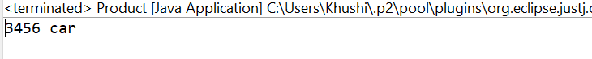

5.

